How a simple railway station-turned music studio became a drawcard for historic Coolgardie
Indiana LysaghtKalgoorlie Miner
Fri, 23 October 2020 6:22AMComments
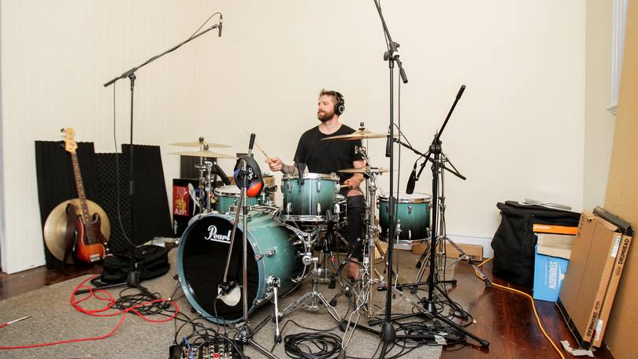Car Park Social’s Jon Carlson
There’s a stone-and-brick building in Coolgardie which used to be bustling with passengers boarding carriages bound for the big smoke.
But now the former railway station’s grand halls resonate to the town’s first creative hub — known as Barefoot Bands.
Left in awe of local talent throughout the Goldfields when attending the annual Leonora Golden Gift, music mentors Brenton Meynell and Drew Goddard of Barefoot Bands knew they could not leave this potential untapped.
Creating opportunities for the community through regional recording projects and arts-based programs came first — writing workshops, community concerts, jam sessions and music lessons have been delivered during the past two years.
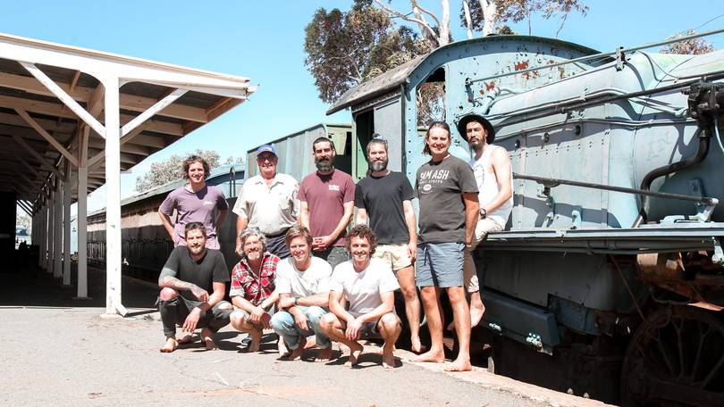Shire of Coolgardie president Mal Cullen alongside musicians utilising the new creative hub. Credit: Indiana Lysaght/Kalgoorlie Miner/Picture: Indiana Lysaght, Indiana Lysaght/Kalgoorlie Miner
And the permanent creative space was not far behind — officially opened a mere two months ago but already making a mark on the music map.
Sitting on the station platform as cymbals played softly in the background, Shire of Coolgardie president Mal Cullen explained why the council jumped at the opportunity to give the Barefoot Band a permanent home, and reinvigorate the railway station.
“It is a historic building in Coolgardie which has always been a community hub as a railway station, with people coming and going on the train for all those years until unfortunately its demise in the late ’60s,” he said.
“With the opportunity for someone like the Barefoot Bands to come through and use it as a recording studio, council and the staff jumped at the opportunity to reinvigorate the building.
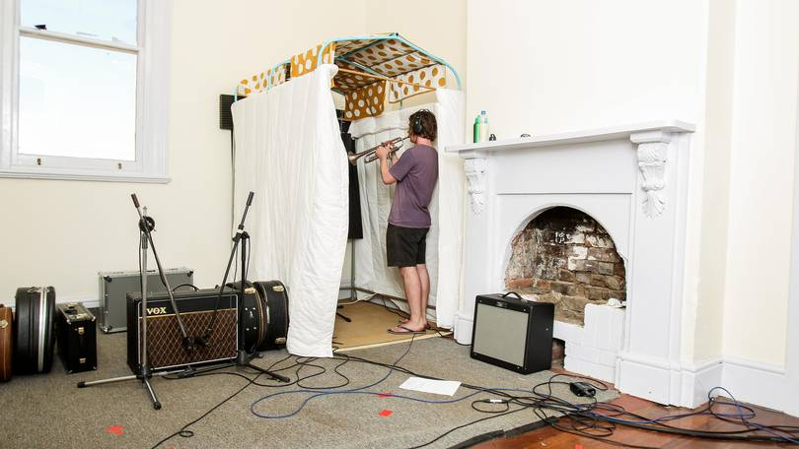Laying down a trumpet track.
“Other than the odd artists who come along to the rec centre during the school holidays program, we don’t have a permanent music or art facility in the town so most of the arts we have in the region go through the arts centre in Kalgoorlie.
“It has definitely been an opportunity for us to promote music in the town with the children and even some of the older residents who have embraced it.”
The lack of a permanent creative centre in Coolgardie may have been in the boys’ favour, but Mr Cullen pointed to their passion and infectious personalities as to why the pair had made such a positive impact on the town.
“They are such a relaxed crew and the atmosphere they create is infectious,” he said.
It is a historic building in Coolgardie which has always been a community hub as a railway station, with people coming and going on the train for all those years until unfortunately its demise in the late ’60s
Mal Cullen
“They are serious in a way with their music but the way they interact, they have that relaxed mannerism and ability to engage with people so they actually draw people to them with their music and that activity.
“What we are hoping is that some of the younger kids will engage with that as well — there is a lot of talent here which can be recognised and might bring something out in the kids as well; instead of running around town and getting up to all sorts of mischief, they might come along and spend a few hours playing music which is great.
“A bit of loud music that these guys are playing during the afternoon and late evening, I don’t think that is worrying our local residents whatsoever — I think they have embraced that as well.”
The regional recording studio is already a magnet for talent.
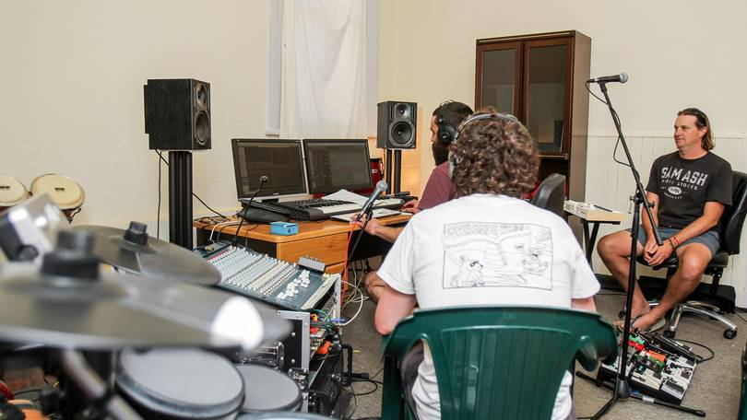Barefoot Bands’ Drew Goddard and Brenton Meynell tracking tunes alongside Car Park Social’s Paul Riccardo. Credit: Indiana Lysaght/Kalgoorlie Miner/Indiana Lysaght/Kalgoorlie Miner
As Cr Cullen spoke, photographer and videographer Jamie Sher floated through the halls with a camera in hand; former Goldfields Giant, musician and videographer Travis Klymiuk-McIlroy, was intermittently swapping a guitar for a camera, while Meynell, Goddard and Chris Edmondson worked with Esperance’s Car Park Social to record their four new tracks.
Just weeks earlier Karnivool came up to record some tracks.
But ever-humble Meynell said Barefoot Bands were just pleased they could deliver opportunities to the grassroots talents tucked away in the Goldfields.
“We have loved recording having Car Park Social from Esperance and we are looking forward to recording and teaching the students over the coming days as well as providing entertainment for the Volunteer Fire and Rescue Service 150 anniversary,” he said.

